Test de aptitudini şi cunoştinţe de limbă modernă pentru admiterea
în clasa a V-a cu program intensiv
PROBA SCRISĂ

I. Read and choose the correct answer: (15 × 1 point = 15 points)

- It’s raining. I’m wearing my ……………………… today.
A. mac B. sandals C. sunglasses
- She works in a restaurant. She serves food and drinks. She is a …………..….
A. waiter B. cooker C. waitress
- What’s the weather like today? It’s...............................
A. sun B. cloudy C. rain
- They usually have breakfast in the................................
A. living room B. bedroom C. kitchen
- The third day of the week is..............................
A. Friday B. Tuesday C. Wednesday 6. People arrange their clothes in a.................................
A. bookcase B. wardrobe C. cupboard
7. What can you buy from a butcher’s? Some ………………….
A. cheese B. meat C. bread
8. She lives in a nice house. Her house is ........................ the park. A .next to B. under C. between
9.She always goes to the gym ………….. Tuesdays.
A. in B. on C. at
- Tom is....................than his sister, Mary.
A. oldest B. old C. older 12. Is there ........................milk in the fridge?
A. some B. any C. no
- What time ………………………… in the morning? A. are you getting up B. do you usually get up C. does you get up
13. There are two ………………. in this picture: a man and a woman. A. person B. mans C. people
14. I like …………………. the piano in the evening.
A. singing B. playing C. play
15. Can I have a …………………. of milk, please?
A. packet B. carton C. bar

II. Read the poster and decide if the sentences are  true (T) or false (F): (5×2 points=10 points)  - You can eat salad in this restaurant. T / F  - This restaurant sells seafood. T / F  - There are four different types of pizza. T / F  - They don't have desserts in this restaurant. T/ F  - The water is free in this restaurant. T / F | 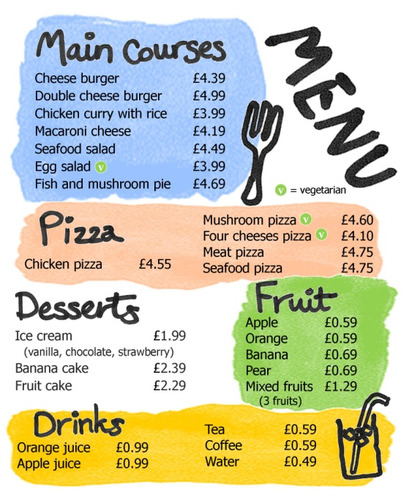

III. Read the story and write some words to complete the sentences about the story. You can use 1, 2 or 3 words. (10×1.5 points=15 points)

My name is Julie. I have a friend. My friend lives in California. My friend is a girl. She is seventeen years old. Her name is Jessica Roberts. Jessica is cool. She likes reading detective stories. She is a good reader. She is good at Maths, too. It is her best subject. We always eat our lunch together on Tuesday and Friday. I like her a lot.

- Julie’s friend name is .................................. …………………….....
- Jessica is …………………………. …………………. old.
- One of her favourite subjects is ………………………
- Jessica also likes reading ……………………... ……….……………….
- They have lunch together on ………………………… …….. …………………….

IV. You want to go to a picnic with your friend, Dan tomorrow morning.
Write a note to Dan. Write 20-30 words. 20 points
Say: ܀where to meet you and at what time.
܀what food to bring.

________________________________________________________________________________________________________________________________________________________________________________________________________________________________________________________________________________________________________________________
NOTA:
- Timp de lucru -1 oră
- Toate subiectele sunt obligatorii
- Se acordă 10 puncte din oficiu
- Punctaj total: 70 puncte

BAREM DE CORECTARE Test de aptitudini şi cunoştinţe de limbă modernă pentru admiterea în clasa a V-a cu program intensiv

SUBIECTUL I – 15 puncte (1 punct pentru fiecare formă corectă)
1. A 2.C 3.B 4.C 5.C 6.B 7.B 8.A 9.B 10.C 11.B 12.B 13. C 14.B 15.B

SUBIECTUL II – 10 puncte (2 puncte pentru fiecare alegere corectă)
- T 2. T 3. F 4. F 5. F

SUBIECTUL III – 15 puncte (1.5 puncte pentru fiecare cuvânt corect)
1. Jessica Roberts 2. years seventeen 3. Maths 4. detective stories 5. Tuesday and Friday

SUBIECTUL IV – 20 puncte
-un vocabular adecvat -5 puncte
-organizarea coerentă şi logică – 5 puncte
- acoperirea sarcinii de lucru cu informaţii cerute- 5 puncte
-începerea ş încheierea biletului prin formulări uzuale- 3 puncte
-încadrarea în numărul de cuvinte specificat – 2 puncte

